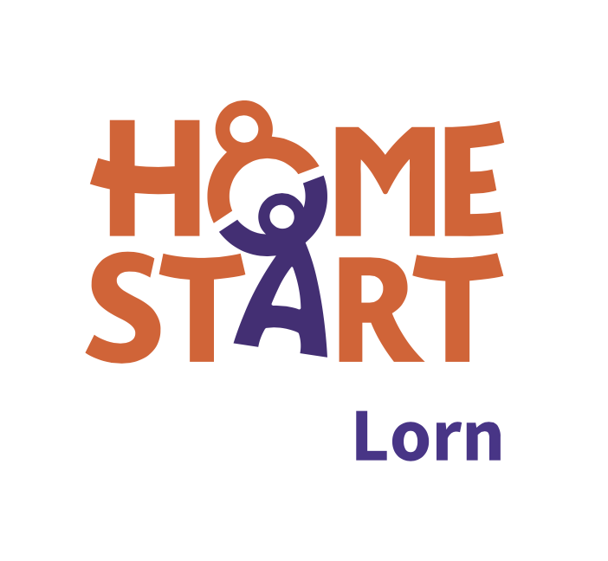***Office use only*** *Referral no: Date received:*

**REFERRAL FORM**

1. **Family Details**

|  |  |  |  |
| --- | --- | --- | --- |
| Main carer surname:  surname | Forename:  forename | | Date of birth:  dd/mm/yyyy |
| Home address:  address | | Postcode: postcode | |
| Main telephone number:  phone | | Email:  email | |
| Immigration status:  Asylum Seeker Refugee | | Ethnicity:  ethnicity | |
| English spoken/understood by main carer?  Yes  No If No, we are unlikely to be able to  support the family | | Other language spoken?  language | |
| Name of partner living in household (if applicable):  name | | Date of birth:  dd/mm/yyyy | |
| Name(s) of other adults living in household:  name | | Previous Home-Start support?  Yes  No | |

|  |  |  |  |  |  |
| --- | --- | --- | --- | --- | --- |
|  | Child’s surname: | Forename: | Date of birth: | Gender: | Addtl needs/disability: |
| 1 | surname | forename | dd/mm/yyyy | select | please describe |
| 2 | surname | forename | dd/mm/yyyy | select | please describe |
| 3 | surname | forename | dd/mm/yyyy | select | please describe |
| 4 | surname | forename | dd/mm/yyyy | select | please describe |
| 5 | surname | forename | dd/mm/yyyy | select | please describe |

**B. Reason For Referral- Please tell us how you would like Home-Start to help your family?** E.g., social isolation, groups, volunteer support, respite, coping with multiple children under 5, coping with own physical/mental health, coping with child(ren)’s physical/mental health. This helps us identify appropriate support measures to introduce.

|  |
| --- |
|  |

1. **Family needs-** So that we offer the most appropriate type of support

Please tick those boxes which apply.

Perinatal  Postnatal depression  Domestic abuse  Mental health issues

Young parent  Lone parent  Learning disability  English not first language  Substance misuse  Disability  Other please specify

1. **Additional information**

|  |  |
| --- | --- |
| Are there any health & safety issues that we need to consider when placing a volunteer with this family? E.g. pets, access to house. | please describe |
| How did you hear about Home-Start Lorn?? | please describe |

**HOW TO SUBMIT THIS FORM**

**Please email referrals** to: [manager@homestartlorn.org.uk](mailto:manager@homestartlorn.org.uk)

***Data Protection*** *The information provided in this form will be held in confidence but may be shown to the family if requested. Information provided by the referrer and the family will be uploaded to our secure cloud-based database and used only for the purpose of providing support, with the family’s additional consent for signposting to other service providers. Our data protection policy will be explained to the family, and consent obtained, at our initial visit. We will seek the ongoing consent of the family as our support continues in compliance with GDPR. Consent for storage of data may be withdrawn at any time by contacting us in writing.*